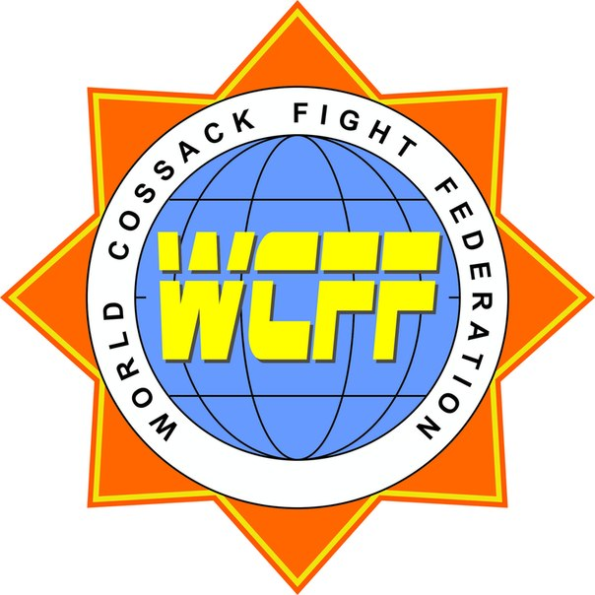

Invitation

WCFF
World Championship - 2021

“Dvobiy” – Cossack Fight
(Ukrainian national Mixed Martial Arts & Shaolin Martial Arts)
men, woman, juniors

1) DATE: 2021 December 11-15

2) PLACE:
Kharkov International Airport
Venue: Ukraine, Kharkov, SPORTS PALACE LOKOMOTIV
3) PROMOTER: Vladimir Radionov

4) ORGANIZERS: World Cossack Fight Federation (WCFF) & World MMA Federation (WMMAF)

5) WEIGHT & PASSPORT CONTROL: 2021 December 12 from 14.00 to 18.00

6) JUDGES AND REFEREES Those who are Interested in participating as judges and referees should be informed, that they are going to attend a seminar. All Delegations are obligated to bring at least one (1) Judge or referee otherwise they will face a penalty

7) CONDITIONS FOR PARTICIPATION Start of the fights: 10.00 a.m. Allowed to start: Fighters of any styles and organizations, with a medical attest.

ENTRY FEE: 40 Euro (per competitor, per style)
- adults men, women, juniors and children. The fighter can participate in different disciplines.

8) ACCOMMODATION Price Hotel 30-50 € in one day, per person (with breakfast and dinner). Information Tel : +38 097 954 52 09,
e-mail: vladibor72@gmail.com

9) DIVISIONS

All styles:
"Odnotan" – musical forms;
"Tan dvobiy" – self-defense;
"Zabava" – point-fighting;
"Bornya 1" - classic light-contact;
"Bornya 2" – MMA Sanda light;
"Bornya 3" – MMA-Light;

"Borot’ba" – Grappling;
"Gerts 1" - classic full-contact;
"Gerts 2" – MMA Sanda full;
"Gerts 3" – MMA-Elite.

Age and weight divisions:

"Zabava" – point-fighting, "Bornya 1" - classic light-contact, "Bornya 2" – MMA Sanda light,

"Bornya 3" – MMA-Light, "Borot’ba" – Grappling;
No | Age | Weight divisions (men)
1 | Veterans (age 41-55 ) |  |  |  |  |  |  |  |  | -65 |  | -75 |  | -85 | +85
2 | Adults (age 19-40) |  |  |  |  |  | -50 | -55 | -60 | -65 | -70 | -75 | -80 | -85 | +85
3 | Juniors (age 16-18) |  |  |  | -40 | -45 | -50 | -55 | -60 | -65 | -70 | -75 | +75
5 | Cadets (age 13-15) |  |  | -35 | -40 | -45 | -50 | -50 | -60 | -65 | +65
6 | Cadets (age 10-12) | -25 | -30 | -35 | -40 | -45 | -50 | +50
7 | Children (age 7- 9) | -25 | -30 | -35 | -40 | +45

No | Age | Weight divisions (women)
1 | Veterans (age 41-55 ) |  |  |  |  |  |  |  |  |  | -65 |  | -75 | -85 | +85
2 | Adults (age 19-40) |  |  |  |  |  | -45 | -50 | -55 | -60 | -65 | +65
3 | Juniors (age 16-18) |  |  |  |  | -40 | -45 | -50 | -55 | -60 | +60
5 | Cadets (age 13-15) |  |  |  | -35 | -40 | -45 | -50 | -50 | -60 | +60
6 | Cadets (age 10-12) | -22 | -25 | -30 | -35 | -40 | -45 | +45
7 | Children (age 7- 9) | -22 | -25 | -30 | -35 | -40 | +40

"Gerts 1" - classic full-contact; "Gerts 2" – MMA Sanda full;

No | Age | Weight divisions (men)
1 | Adults (age 19-40) |  |  |  |  | -50 | -55 | -60 | -65 | -70 | -75 | -80 | -85 | -90 | +90
2 | Juniors (age 16-18) |  |  | -40 | -45 | -50 | -55 | -60 | -65 | -70 | -75 | +75
No | Age | Weight divisions (women)
1 | Adults (age 19-40) |  |  |  |  | -50 | -55 | -60 | -65 | -70 | -75 | -80 | -85 | -90 | +90
2 | Juniors (age 16-18) |  |  | -40 | -45 | -50 | -55 | -60 | -65 | -70 | -75 | +75

"Gerts 3" – MMA-Elite.
No | Age | Weight divisions
1 | Adults (age 19-40) (men) |  | -56 | -60 | -65,8 | -70,3 | -77,1 | -84 | -93 | +93
2 | Adults (age 19-40) (women) | -50 | -55 | -61 | -68 | -76 | +76

MUSICAL FORMS: Hard Styles, Soft Styles, Hard Styles weapons, Soft Styles weapons.

10) PROGRAM OF THE EVENT
December 11: Arrival of the Teams;

December 12:
14.00-18.00 Registration, Weight Control and Medical Examinations, Meeting representatives

December 13:
10.00 Open Ceremony, Preliminary Fights for all styles, Semi-Final Fights for all style,

December 14:
10.00 Final Fights for all styles, Awards ceremony.
December 15: Departure of the Teams
11) CONTACT – VISA DOCUMENTS For more Information or Visa Documents please contact:
+38 097 954 52 09
Visa is not required for citizens of the EU, the UK, the USA, Israel, Japan and some other countries. For further information contact the nearest consulate or embassy. http://www.mfa.gov.ua/mfa/en/publication/content/1865.htm

e-mail: vladibor72@gmail.con

http://wcff.info/

 | Registration form – WCFF World Championship
 | Competitors
 | Name | Country/Club | M / F | Year of Birth | Weight |  | G1 |  | G2 |  | G3 |  | B1 |  |  | B2 |  |  | B3 |  | Z
1
2
3
4
5
6
7
8
9
10
 | Coaches / Representatives
 | Name | Country/Club | coach/representative/…
1
2
3
4
5
 | Referees / Judges
 | Name | Country/Club
1
2
3
4
M / F = male or female
G1 – Gerts (Full contact)
G2 – Gerts (MMA Sanda)
G3 – Gerts (MMA Elite)
B1 – Bornia-1 (light contact)
B2 – Bornia-2 (MMA Sanda light)
B3 – Bornia-3 (MMA light)
Z – Zabava (point-fight)

Arrival & Departure Details
Country: ________________________________________________
National Federation/Association's Name: ______________________________________________
Name of Representative: ___________________________________________________
Address: ___________________________________________________
E-mail:_________________________
Telephone / Fax: __________________
Flight Schedule:
Date of Arrival: ___________________ Time of Arrival: _______________ No. of
Persons: ______________________________ Flight No: _________
Airline Name: ______________________
Date of Departure: ___________ Time of Departure: ________________ No. of
Persons: ______________________________ Flight No: _________
Airline Name: ______________________
For visa support must send a copy of passport and fill out a form:
№ | Name & Surname | M/F | Passport No. | Date of passport issue and expiry | Date of Birth | By whom  passport  given | Home address | Status
 | 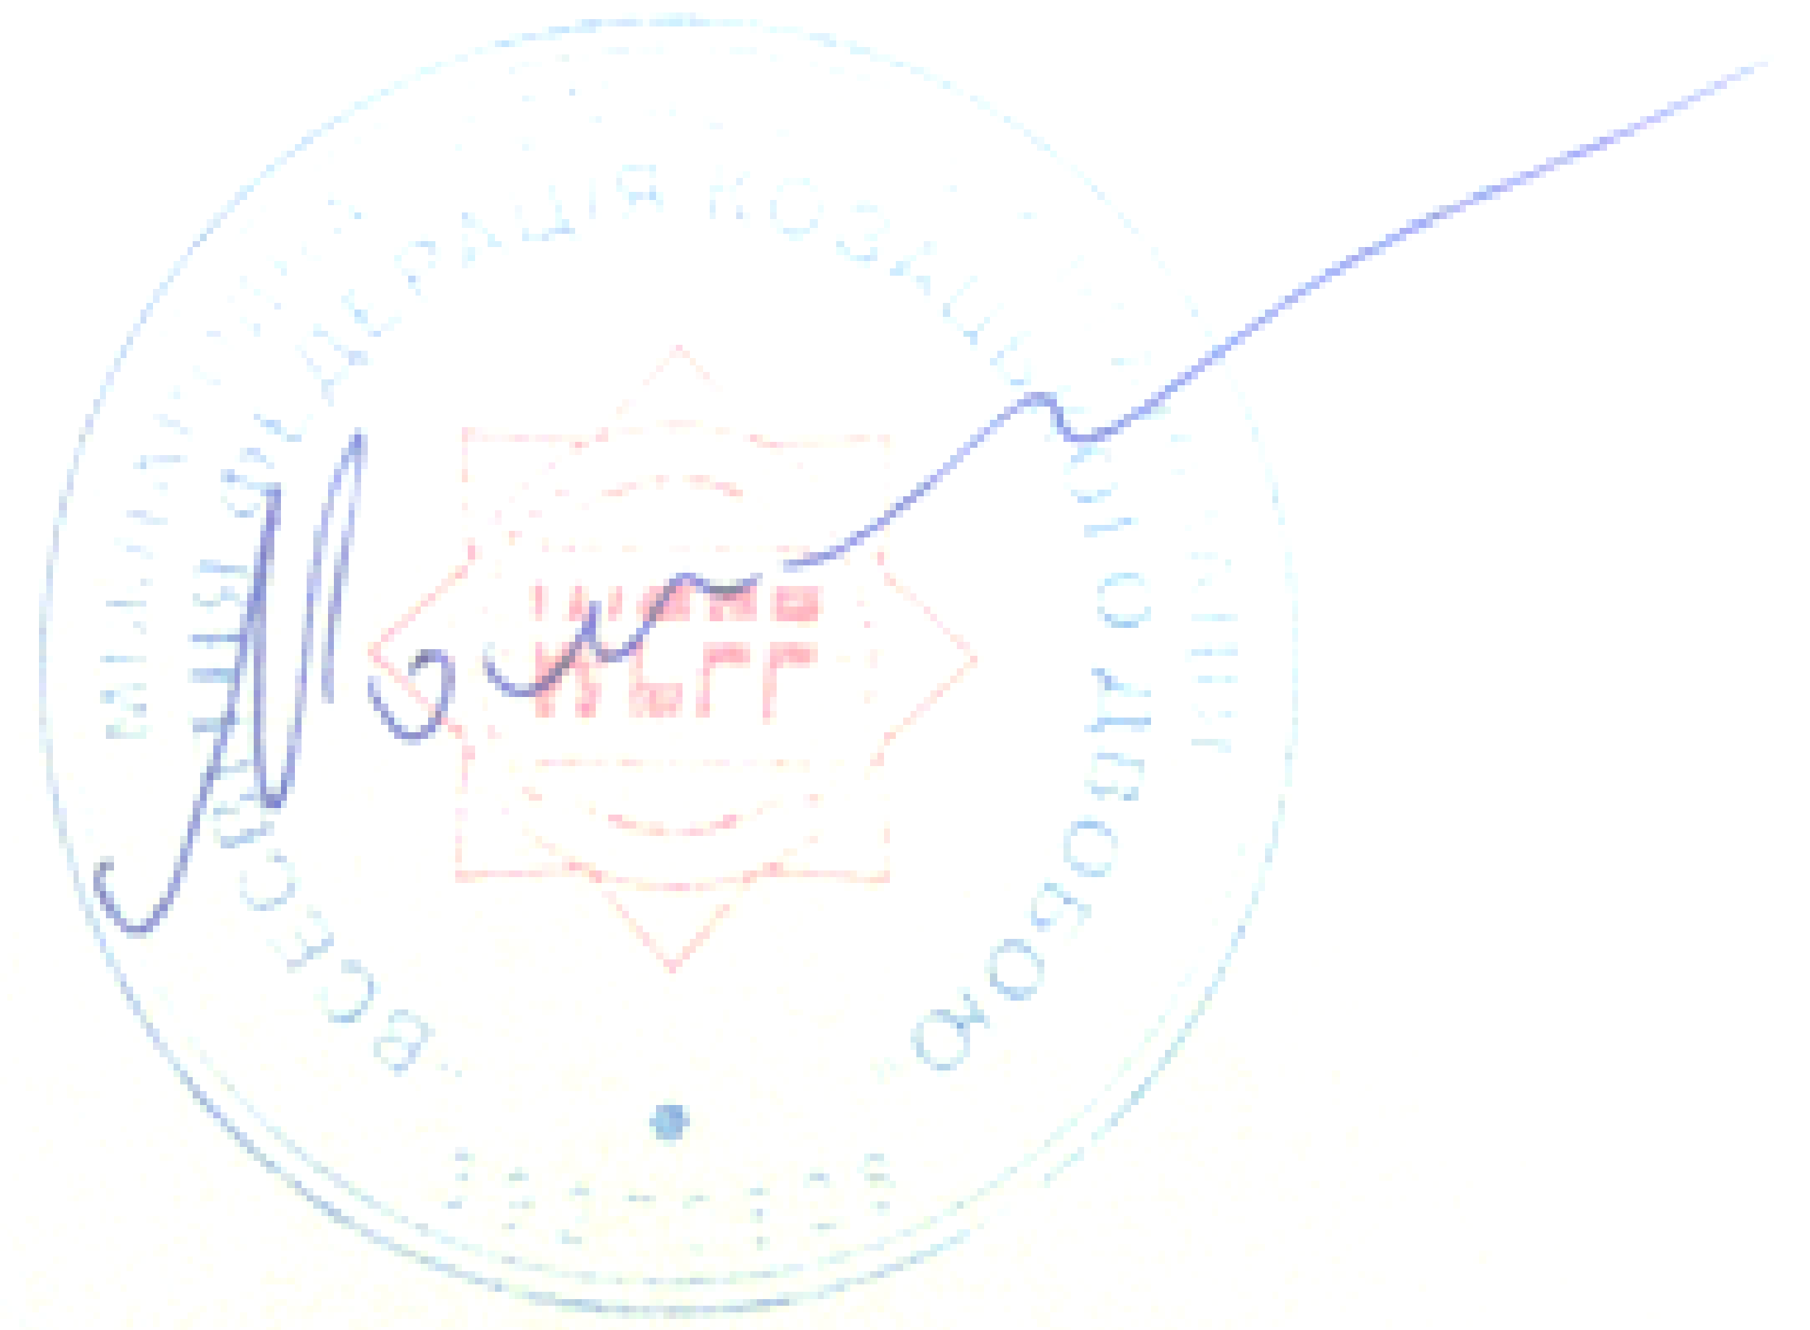

vladibor72@gmail.com
President WCFF V. Moshkovskii

