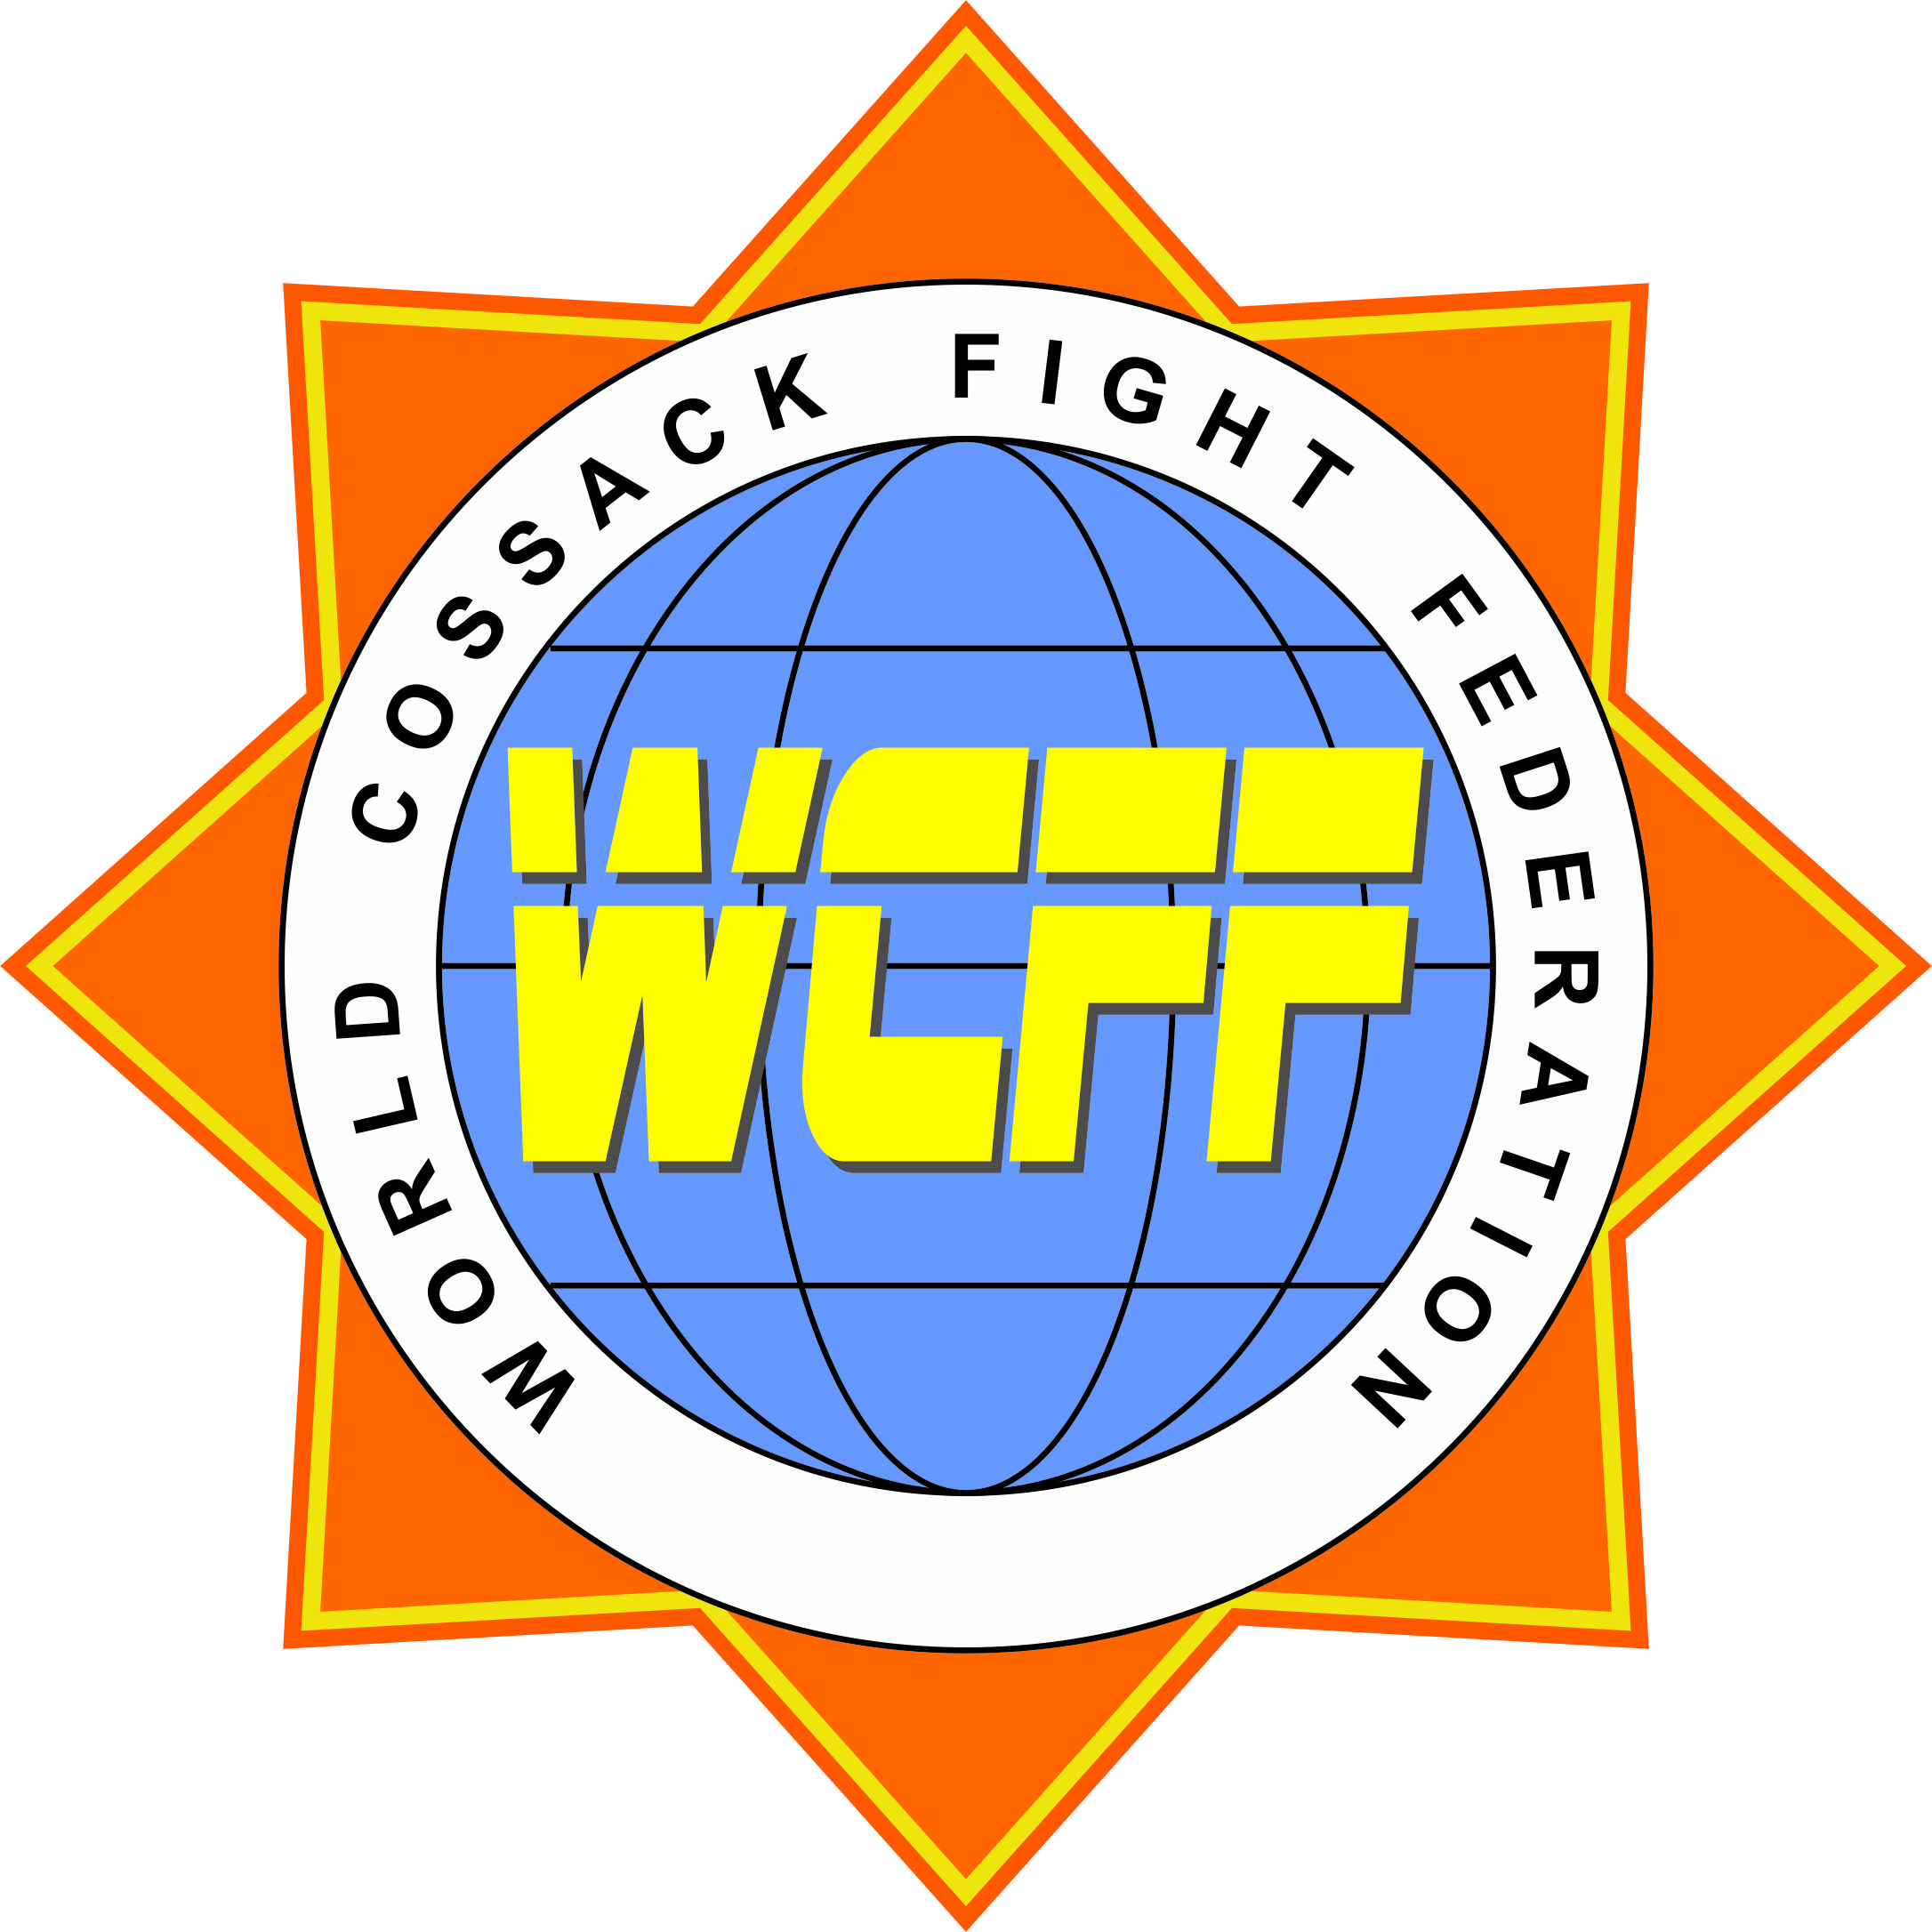

WORLD COSSACK FIGHT FEDERATION
Ukrainian national form of MMA
____________________________________________________________________________________________________________________________________

Cossack Fight – “Dvobiy”
Calendar of Events for 2014
- Open Russia Championship (Gerts, MMA) February Russia
- National Cup (Open Ukrainian Cup) 14-16 March Dneprodzerzhinsk (Ukraine)
- WCFF European Cup (Adults) 4-6 April Kyiv (Ukraine)
- WCFF Open European Championship 4-6 May Anapa (Russia)
- WCFF World Cup 15-20 June Feodosia (Ukraine)
- WCFF Open European Cup (Junior) 20-25 August Feodosia (Ukraine)
- World Cup of Martial Arts (PAMA) 3-7 October Yalta (Ukraine)
- WCFF Open Ukrainian Championship 13-15 October Kyiv (Ukraine)
- WCFF World Championship November Kharkiv (Ukraine)

