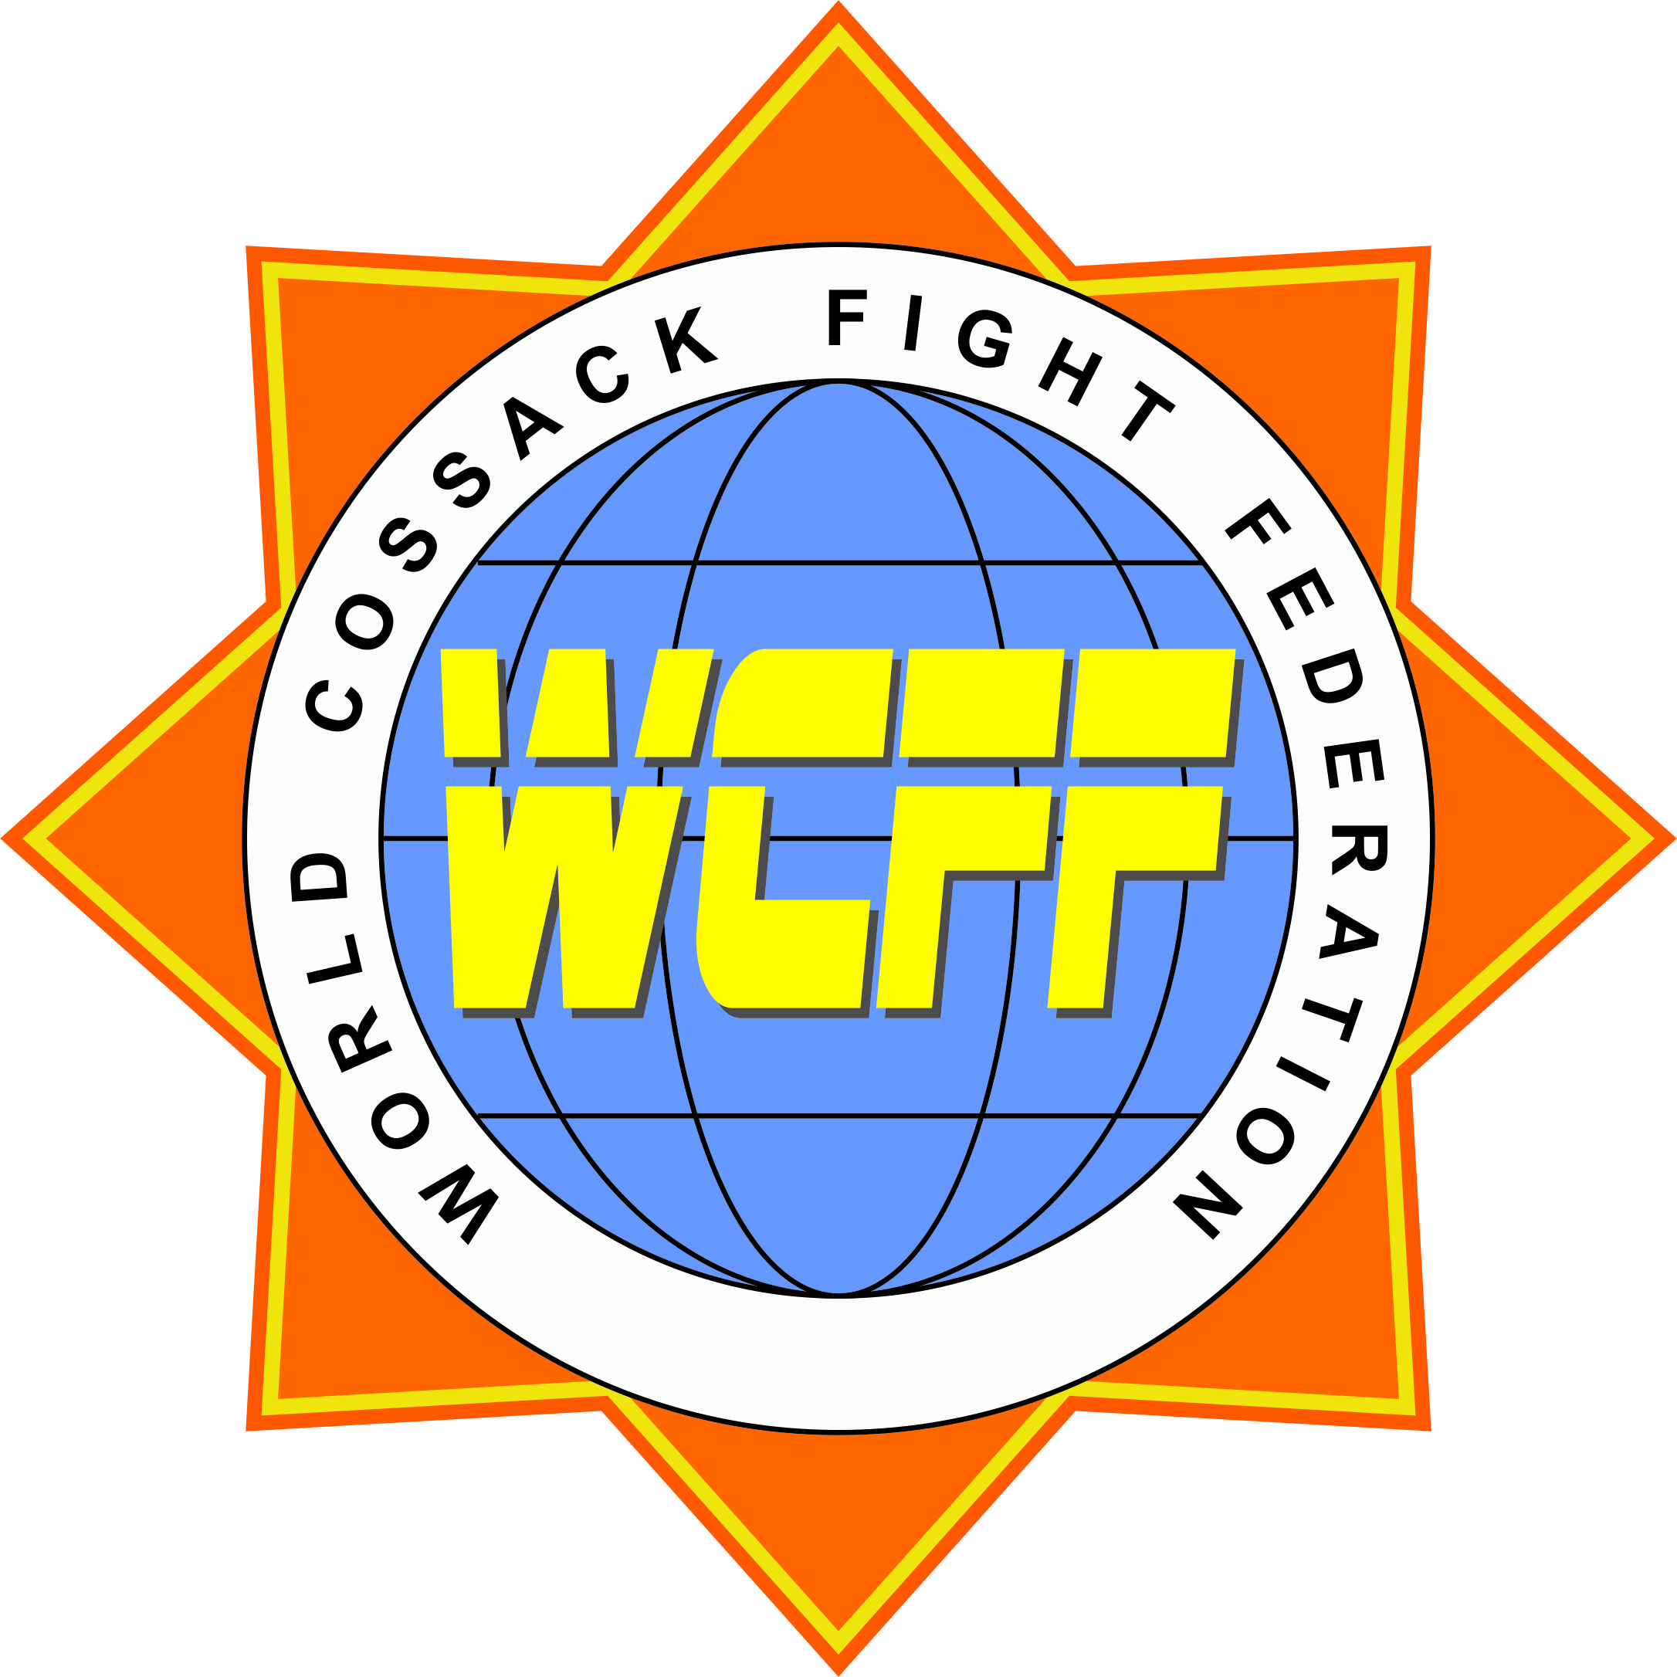

WORLD COSSACK FIGHT FEDERATION
Ukrainian national form of MMA
____________________________________________________________________________________________________________________________________

Cossack Fight
Calendar of Events for 2013
- Olympics of Martial Arts (IUMA) 23 March Kiev (Ukraine)
- National Championships (Open Ukrainian Cup) 29-31 March Dneprodzerzhinsk (Ukraine)
- European Championship (WCFF) 26-28 April Kharkov (Ukraine)
- International Tournament “Kievan Rus Cup” May Kiev (Ukraine)
- World Championship (WCFF) 15-20 June Feodosia (Ukraine)
- National Championships (Ukrainian Championship) 20-25 August Feodosia (Ukraine)
- World Cup (WCFF) 3-7 October Yalta (Ukraine)

